2.6

> book=imread('book.jpg');

>> imshow(book)

>> [X Y]=ginput(4)

X =

142.8299

307.4525

256.9026

3.2586

Y =

27.8998

47.5829

216.6789

159.8663

x=[142 307 256 3];

>> y=[27 47 216 159];

%X means the changed image

>> X=[1,210,210,1];

>> Y=[1,1,297,297];

>> V=[X(1) Y(1) X(2) Y(2) X(3) Y(3) X(4) Y(4)]’;

>> A=[x(1) y(1) 1 0 0 0 -X(1)\*x(1) -X(1)\*y(1);

0 0 0 x(1) y(1) 1 -Y(1)\*x(1) -Y(1)\*y(1);

x(2) y(2) 1 0 0 0 -X(2)\*x(2) -X(2)\*y(2);

0 0 0 x(2) y(2) 1 -Y(2)\*x(2) -Y(2)\*y(2);

x(3) y(3) 1 0 0 0 -X(3)\*x(3) -X(3)\*y(3);

0 0 0 x(3) y(3) 1 -Y(3)\*x(3) -Y(3)\*y(3);

x(4) y(4) 1 0 0 0 -X(4)\*x(4) -X(4)\*y(4);

0 0 0 x(4) y(4) 1 -Y(4)\*x(4) -Y(4)\*y(4)];

>> w = U\*[X; Y; ones(1,4)];

>> w = w ./ (ones(3,1) \* w(3,:))

w =

-239.2247 57.6873 198.1278 81.8978

-31.1659 -119.9287 371.6333 411.0977

1.0000 1.0000 1.0000 1.0000

>> T = maketform('projective', U');

>> P2 = imtransform(P, T, 'XData', [0 210], 'YData', [0 297]);

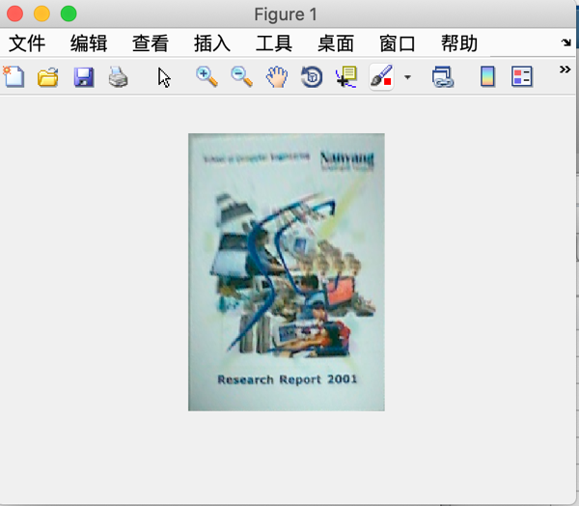

Yes , it is .